Given two binary search trees, return True if and only if there is a node in the first tree and a node in the second tree whose values sum up to a given integer target.

**Example 1:**

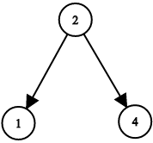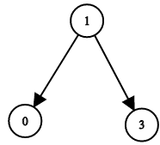

**Input:** root1 = [2,1,4], root2 = [1,0,3], target = 5

**Output:** true

**Explanation:** 2 and 3 sum up to 5.

**Example 2:**

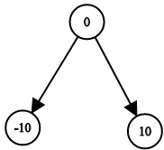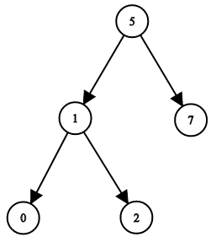

**Input:** root1 = [0,-10,10], root2 = [5,1,7,0,2], target = 18

**Output:** false

**Constraints:**

* Each tree has at most 5000 nodes.
* -10^9 <= target, node.val <= 10^9